Buy Verified TransferWise Account 100% Secure & Instant Delivery
Are you looking to buy a verified TransferWise account to make international transactions easier, faster, and more reliable? You’ve come to the right place! TransferWise, now known as Wise, is one of the most trusted online money transfer platforms in the world, offering seamless cross-border payments at the lowest fees. Whether you are a freelancer, business owner, or investor, having a verified TransferWise account helps you send and receive money globally without any restrictions.
When you buy a verified TransferWise account, you get access to fully activated features, including multi-currency wallets, fast payments, lower exchange rates, and enhanced account security. If you need a safe and efficient way to manage international payments, this is the perfect solution.
Are you searching for the best place to buy a verified TransferWise account? If yes, then you’re in the right place! A verified TransferWise account (now called Wise account) gives you access to secure, fast, and affordable international money transfers. Whether you are a freelancer, business owner, or online entrepreneur, a verified account makes global transactions smooth and hassle-free.
When you buy a verified TransferWise account, you avoid the lengthy manual verification process and get instant access to all features. This is perfect for people who want a fast, safe, and ready-to-use account for personal or business purposes.
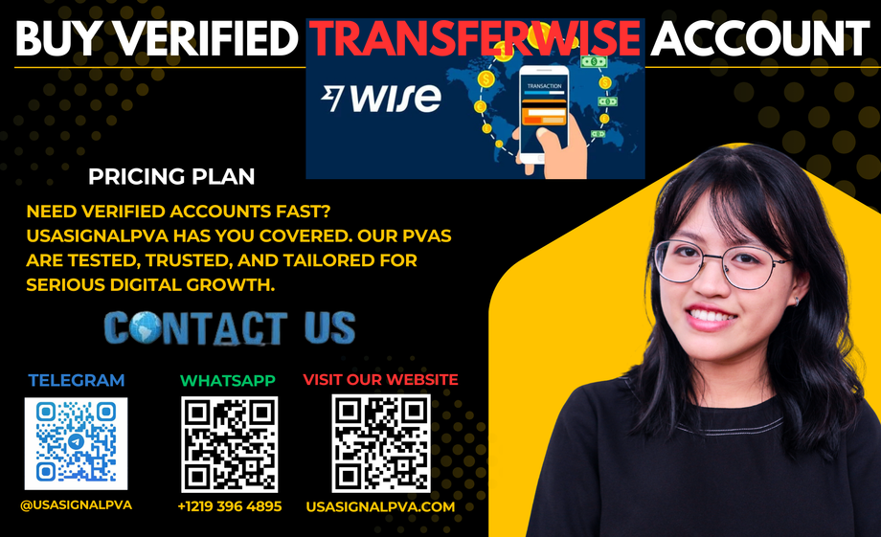

What is a TransferWise Account?
A TransferWise account (now called Wise account) is an online financial service that allows you to send, receive, and hold money in multiple currencies. It’s widely used by businesses, freelancers, and individuals who deal with global clients. Some of its top benefits include:
Multi-currency support – Hold balances in 50+ currencies.Low fees & real exchange rates – Save more on international transfers.Fast transactions – Send and receive money in minutes.Virtual bank details – Get local bank accounts in different countries.Safe & reliable – Trusted by millions of users worldwide.
Having a verified TransferWise account unlocks all these benefits and ensures your account has no sending or receiving limits.

Why Buy a Verified TransferWise Account?
Buy verified TransferWise account saves you time and effort. Manual verification often requires submitting ID documents, proof of address, and waiting for approval. By purchasing a ready-made, verified account, you get:
Instant access – Use your account right away.Verified identity – Fully approved and KYC-compliant.No transfer limits – Send and receive without restrictions.Business-friendly features – Perfect for freelancers and entrepreneurs.Global accessibility – Manage international payments easily.
This is ideal for anyone who needs a fast, secure, and verified financial solution.

How to Buy a Verified TransferWise Account Today
If you’re wondering, “How to buy a verified TransferWise account?” — the process is simple and hassle-free:
Choose the right package – Select the account type (personal or business).Place your order – Submit your details securely.Get instant delivery – Receive login credentials within minutes.Start transacting – Enjoy unlimited global transfers.
With our secure process, you can buy a verified TransferWise account today and start sending or receiving money globally without any delays.
If you want to make international transfers today, you can buy a verified TransferWise account and start transacting immediately. With a pre-verified account, there’s no need to wait for approval. You get instant login credentials, secure access, and complete account features.
Whether you need it for personal use or business purposes, getting a verified account today is the best way to save time and start managing your finances globally.

How To Do Buy Verified TransferWise Account?
If you’re wondering, “How to buy a verified TransferWise account?”, here’s a simple guide:
Choose Your Account Type – Select personal or business.Place Your Order – Provide the required details securely.Receive Your Account – Get login credentials within minutes.Start Using It – Send, receive, and manage funds globally.
With this process, you can buy a verified TransferWise account safely and start using it instantly.

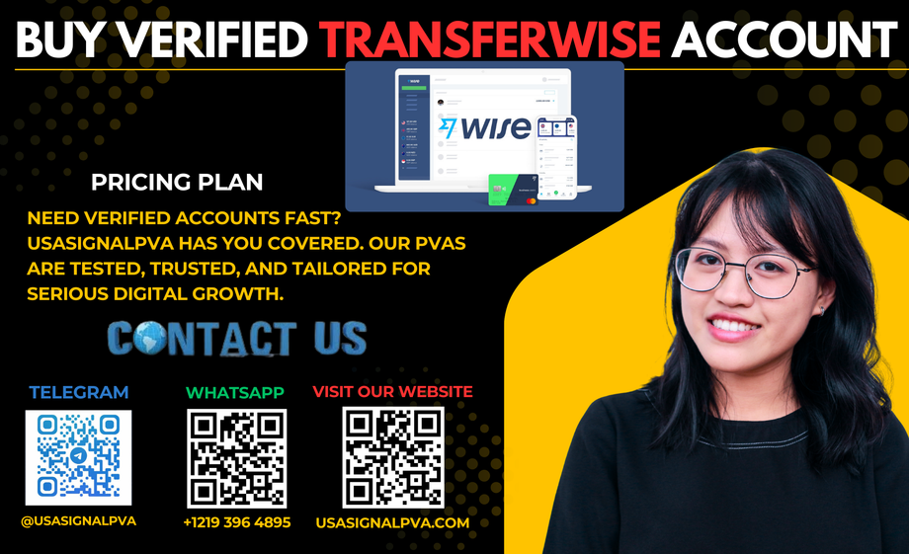

Final Thoughts
A verified TransferWise (Wise) account is the key to smooth, fast, and affordable international transactions. Whether you’re a freelancer working with overseas clients, an e-commerce seller, or a business handling global payments, buying a verified account gives you instant access to all premium features.
So, if you want to buy a verified TransferWise account safely and instantly, today is the best time to get started. Simplify your cross-border payments, manage multiple currencies, and enjoy a hassle-free financial experience.
A verified TransferWise (Wise) account is the ultimate solution for seamless global payments. Instead of wasting time on lengthy verification procedures, you can buy a verified TransferWise account today and enjoy instant access to all features.
Whether you are a freelancer, business owner, or international trader, this is your chance to manage global finances easily and securely. Get your verified account now and start sending and receiving money worldwide — fast, secure, and hassle-free.

